
My target: _____ /40 ; or _____%
Score:
/40

YEAR 8 Humanities and Social Sciences
ASSESSMENT 3: The Black Death- IN CLASS SHORT ANSWER RESPONSE

Name: ______________________________ Date:

Attempt all questions on this sheet. Please complete the multiple-choice section using a pencil!!

Multiple Choice: Read each key term, or statement, and circle only one option from A-D with a pencil as your response.
(14 marks)
- In what years did the Black Death peak in Medieval Europe?
  - 1147-1151
  - 1347-1351
  - 1947-1951
  - 2007-2011

- The Black Death is also known as:
  - Blue Plague
  - Death Plague
  - Bubonic Plague
  - Grim reaper Plague

- Results of the Black Plague included:
  - The death of tens of millions of people
  - The decline of cultural transmission and trade across Eurasia
  - The halting of growth of population, trade and industry
  - All of the above

- Historical records indicate that the Black Death started in:
  - South America
  - China
  - Italy
  - South-East Asia

- The Plague had all of the following effects on society EXCEPT:
  - People affected by it developed swellings underneath their armpits and purple blotches on the skin.
  - Many people became angry and bitter towards the church
  - It caused people to shun the families of the sick and refugees from afflicted communities
  - It eventually inspired European doctors to make major strides in medicine.

- The particular epidemic of the fourteenth century originated in Asia and traveled to Europe via trade routes. Among them was what ancient trading route?
  - The China Byway
  - The Mongolian Passage
  - The Silk Road
  - The Tea Route

- "Bubonic" is only one form of plague; the disease also manifested itself in other variations, including one form that was airborne and spread via coughing, sneezing and breathing. What is the term for this variety of plague?
  - Enteric
  - Organic
  - Pneumonic
  - Septicemic

- In 1300, Europeans' average life expectancy was ____ years.
  - 70-75
  - 44-48
  - 80-92
  - 28-30

- Reasons the Black Death subsided are;
  - Decline of travel for a period of time
  - Quarantine
  - Practicing proper hygiene
  - All of the above

- Flagellants were a religious group who;
- Believed the Black Death was caused by an imbalance of the four humours
- Believed whipping themselves would show their willingness to God.
- Believed Jewish people were responsible for the Black Death.
- Believed that disease was caused by bad smells.

- The Black Death was caused by a bacterium known as;
- Yersinisee pesticise
- Pestical plague
- Yersinia pestis
- Yersillnia pestililence

- Which of the following was not due to the Black Death?
- Normal life broke down
- People began to lose faith in the church
- The hundred year war began
- The economy suffered

- Which of the following is true of the Black Death?
  - The virus was carried by rats and transmitted by fleas
  - It sometimes started with tumours that would grow under the armpit and groin
  - It was also known as the Bubonic plague
  - All of the above are true.

- During the siege at , the Tartars used Trebuchets to catapult infected bodies over the cities walls.
- Caffa
- Hubei
- Naples
- Genoa

END OF MULTIPLE CHOICE

Short Answer Response:
(3 marks)
- Read the following extract carefully. Use the words provided below to fill in the blanks.

“The Black Death appears to have been a combination of three related diseases, all of which had different symptoms and different ways of being transmitted. The first of these was the plague, which was named so because pus filled swellings appeared on the lymph nodes. Another form was the plague; this plague attacked the lungs and was always fatal. The third form was the plague, which aggressively affected the bloodstream. In this form the bacteria multiplied so fast the person would die in hours of catching the infection.”
(bubonic, pneumonic, septicaemic)

Source 1:

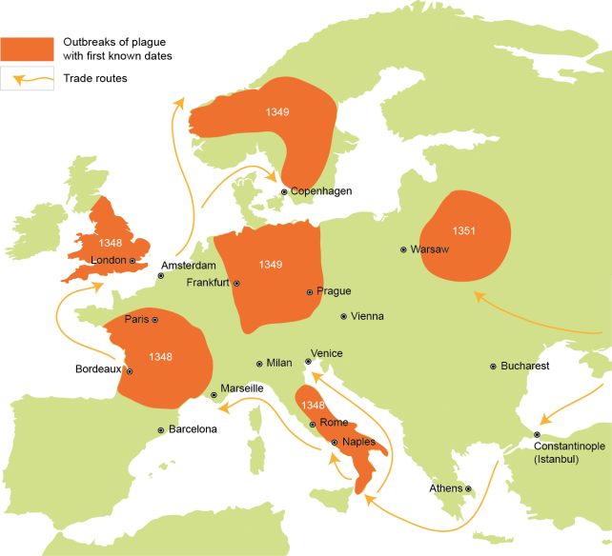

- With reference to source 1 explain how the Black Death was able to spread quickly throughout Europe. (2 marks)
(HINT: A good response will include prior knowledge of the topic to explain how Source 1 shows how the Black Death spread so quickly throughout Europe)

- Answer the question below referring to source 2.

Source 2:
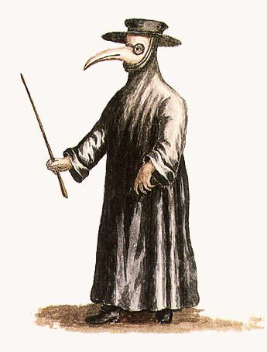
A doctor dressed up to fight the Black Death as shown in a seventeenth century manuscript.

- Is the source a primary or secondary source document? Explain your choice.
(3 marks)

- How effective do you think the outfit of the doctor was in fighting the Black Death
(4 marks)

- Read the source below and answer questions below;
Source 3:
Source E was written by Henry Knighton, a man who lived through the Black Death and described its immediate effects in his book History of England from the 14th century.
“Sheep and cattle went wandering … and there was no one to go and drive or gather them … many crops perished in the fields for want of someone to gather them.
But the peasants were so lifted up and obstinate that they would not listen to the king's command, but if anyone wished to have them he had to give them what they wanted, and either lose his fruit and crops, or satisfy the wishes of the workmen.
After the pestilence, many buildings, great and small, fell into ruins in every city for lack of inhabitants, likewise many villages and hamlets became desolate … it was probable that many such villages would never be inhabited.”

- List three immediate effects of the Black Death described in Henry Knighton’s writing
(3 marks)

- Knighton described the buildings that “fell into ruins” and the “desolate” villages. What does this information tell you about the impact of the Black Death on populations in Europe?
(2 marks)

- Of the effects in your list explain which effect would have had the greatest impact on society at the time. Be sure to use your understanding of the time period to formulate your response.
(3 marks)

- Read Source 4 and then answer the question below;
Source 4: (2 marks)
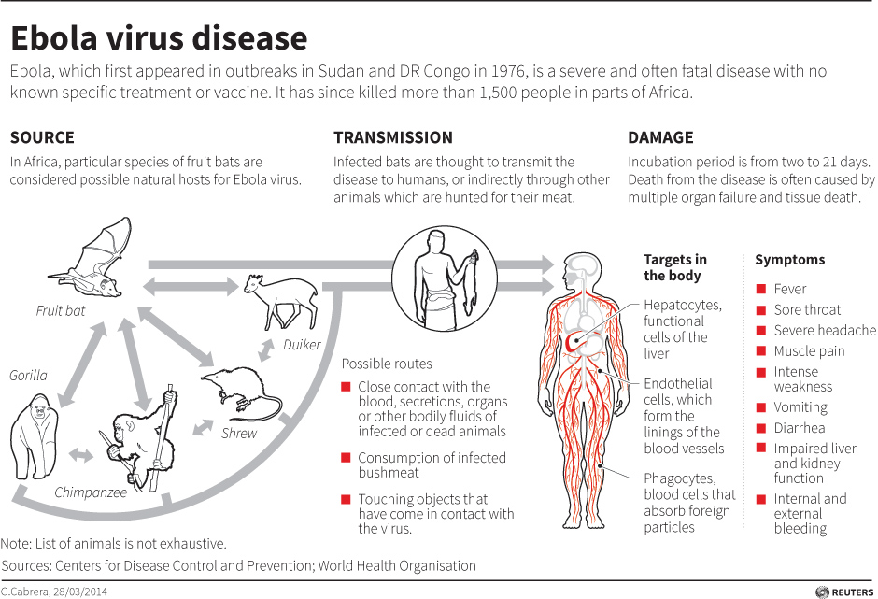

Using your own knowledge and Source 18, what is one similarity and one difference between the source of the Ebola virus and the source of the Black Death.
Similarity:
_______________________________________________________________________

Difference:
______________________________________________________________________

- The Black Death was responsible for the death of 50 million people throughout Europe and Asia during the 14th century. The Black Death disease is still present today however few people have died from the disease in recent times. Explain why the Black Death does not have the devastating effects today that it did in the 14th century?
(4 marks)

END OF TEST

